ASSIGNMENT – 05

Name: T. Jithendra

Register Number: 192111521

Course Code: DSA0163

Course Name: Object Oriented

Programming with C++

using single catch:

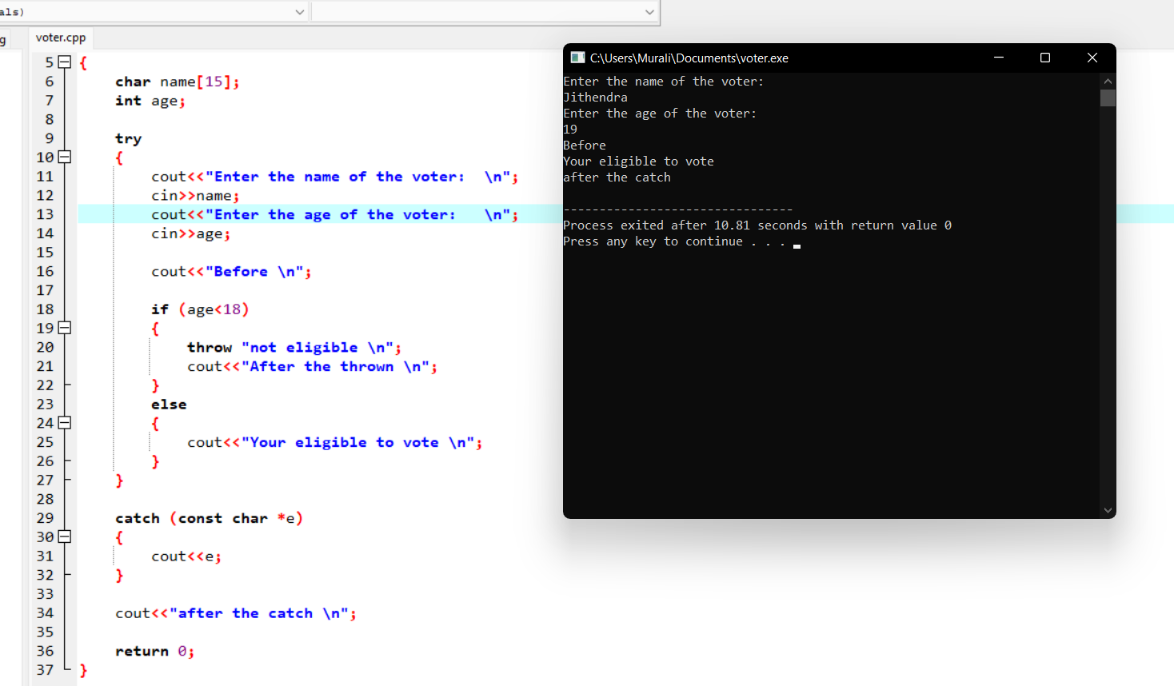

Using multiple catch:

